Ryan Ellis
COSC 220-003
Project #3: Process Simulations
Section 3.5 – System Analysis
11/25/2024

Recorded Output Findings
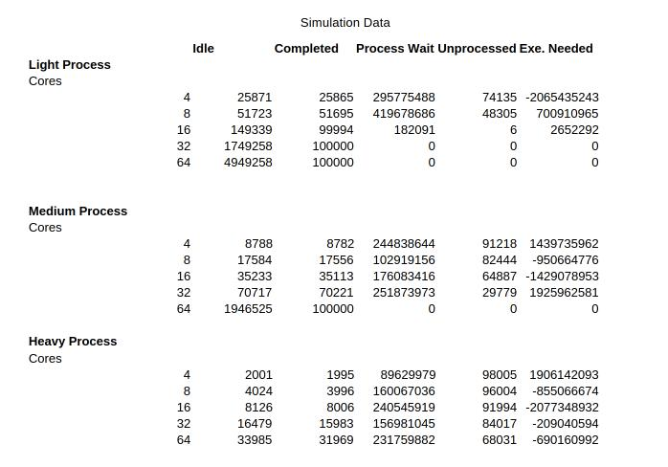Figure 1: Simulation Data of Light, Medium, and Heavy Process Loads
Light Process Analysis
Reviewing the data above, it is clear that as the core size increases, so does the optimization of the processing capability, and ultimately the idle time. This is indicative that as the core size grows, it has more than enough capability to handle the load of processes at this level. As the core size increases by a factor of 2, it can be noted that the processes that are completed, or load scale, also grows by a factor of 2 as well.
Medium Process Analysis
Moving into the medium range of load scaling, it is mirrored that as the core size increases, so does the optimization of the processing capability, and ultimately the idle time. However, as the core sizes increased, this load scaling proved to be of a more optimal weight for the cores overall. Noting that as the core size increases by a factor of 2, the same result from before shows true here that the processes that are completed, or load scale, also grows by a factor of 2 as well.

Heavy Process Analysis
Finally looking at the heavy range of load scaling, the same principle of increased core size proportionally increasing processing capability is shown true. Furthermore, with this level of load scaling, even as the core size increases, the CPU is still strained to process the heavy workloads. It can be noted that as the core sizes are doubled, the completed processes tend to also double, holding true from the same principle aforementioned.
Anomalies
Given the somewhat fallible structure of the program, there are a few erroneous values that are given within the data set. Within the “Exe Needed” column, it should be noted that the negative values indicate some error within the coding structure. Nonetheless, the values given for the idle time and completed process are a solid indication of the outcomes that solidify the principles within this exercise.

